

Modern Power Electronics Technology

Experiment Report

**Name**

**Teacher 魏春**

**Class 控制科学与工程XXX班**

**College** **信息工程学院**

January 15, 2021

CONTENTS

# 1 Simulation of Buck-Boost converter Small-signal model in CCM mode

## 1.1 Derivation of Buck-Boost converter model

Buck-boost converter is a typical DC/DC converter with the functions of Boost and Buck, as shown in Fig.1-1.



Fig.1-1 Buck-Boost converter

When the inductor current is continuous, a switching cycle can be divided into two phases.In stage 1, i.e. [t, t + dTs], at switching position 1, the equivalent circuit is shown in Fig.1-2. At stage 2, i.e., [t + dTs, t + Ts], and at switching position 2, the equivalent circuit is shown in Fig. 1-3.



Fig.1-2 Working state 1



Fig.1-3 Working state 2

### 1.1.1 Formulation derivation of large signal model

When the converter operates at state 1, the voltage between the inductors is



The current through the capacitor is



When the converter operates at state 2, the voltage between the inductors is



The current through the capacitor is



So the average inductance voltage in one switching cycle is



If the input voltage and the output voltage are continuous and vary very little during a switching cycle, the following approximation can be obtained





So



Since



That



Similarly





### 1.1.2 Formulation derivation of small signal model

If the input voltage and duty cycle are slightly perturbed near the DC operating point, i.e





Which will cause small perturbations of each state quantity and input current in the buck-boost converter, i.e







By substituting these formulas into the large signal model, the state space average equation after perturbation can be obtained



If the perturbation is small



Then the second-order AC term can be ignored and can be simplified as



Similarly





## 1.2 Simulation of Buck-Boost converter in CCM mode

MATLAB /Simulink is used to simulate Buck-Boost small-signal AC model. The circuit static operating points are selected as follows: output voltage V=200V, input voltage Vg =-200V, control duty cycle D=0.5, inductor L=500uH, capacitor C=47uF, load resistance R=10, inductor current I=40A.The Buck-Boost simulation model is shown in Fig.1-4.

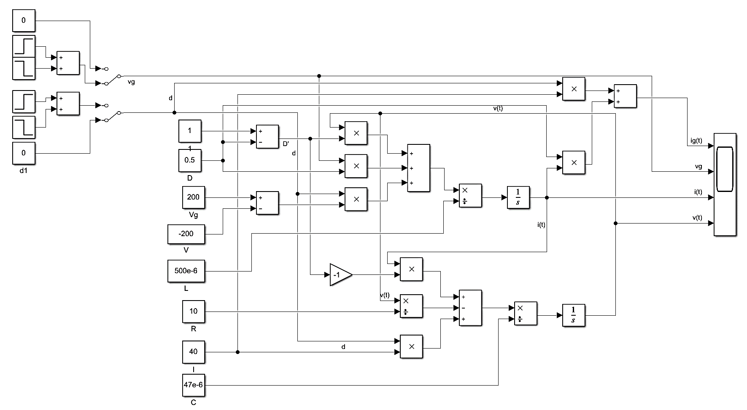

Fig.1-4 CCM small-signal AC model simulation diagram of Buck-Boost circuit

The small-signal AC model simulates the influence of small disturbance on the steady state of the system. When the duty cycle D has a pulse disturbance of 0.02, the output voltage disturbance is V=-15V and the inductance current disturbance is I =5A. The simulation results are shown in Fig.1-5(a). When the duty cycle D has a pulse disturbance of -0.05, the output voltage disturbance is V=40V, and the inductance current disturbance is I =-12A. The simulation results are shown in Fig.1-5(b).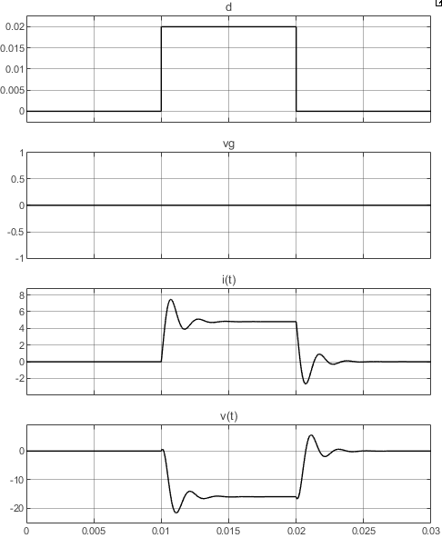 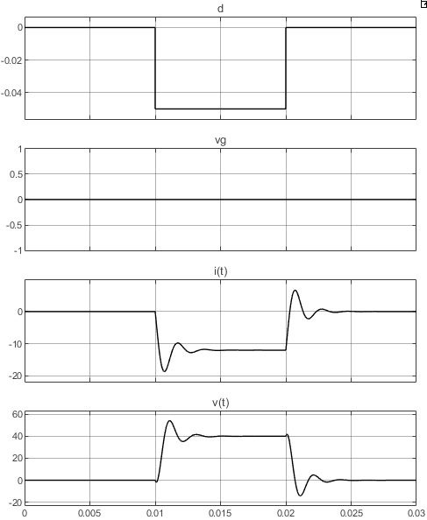

(a) Duty cycle increases by 0.02 (b) Duty cycle Decreases by 0.05

Fig.1-5 Simulation results when the duty cycle is disturbed

When the input voltage increases by 20V, the output voltage perturbation is V=-20V and the inductance current perturbation is I =4A. The simulation results are shown in Fig.1-6 (a). When the input voltage is reduced by 60V, the output voltage perturbation is V=60V and the inductance current perturbation is I=-12A. The simulation results are shown in Fig.1-6 (b).

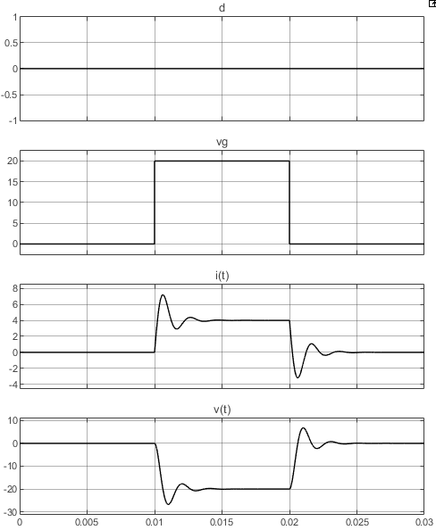 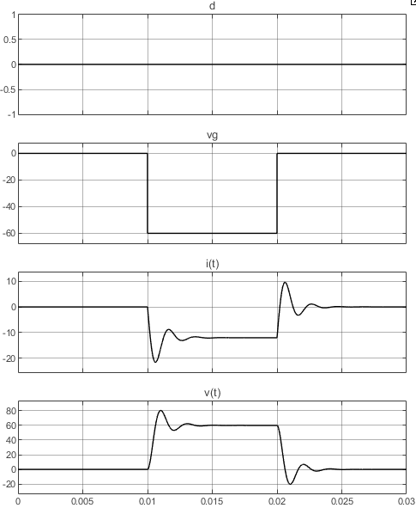

(a) Input voltage increases by 20V (b) Input voltage Decreases by 60V

Fig.1-5 Simulation results when the input voltage is disturbed

## 1.3 Summary

The small-signal model of the circuit linearizes a certain steady-state operating point of the circuit, linearizes the nonlinear large-signal model, and only retains the disturbance component of the circuit electric quantity, which excludes the steady-state component and switching ripple.

In this experiment, the small signal model of Buck-Boost circuit is simulated, and the operation results of the small signal model of Buck-Boost circuit under various perturbations are simulated. Meanwhile, the linearization characteristics of the small signal model are verified.